Adding a new menu on Joomla 3.X
To add a new menu which can hold menu items do the following:

1. Log in to the Joomla! Administrator Back-end.
2. Click Menus > Menu Manager on the toolbar menu. The Menu Manager screen opens.
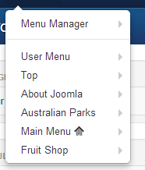

3. Click the New toolbar button. The New/Edit Menu screen opens.

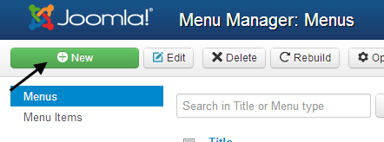

4. Complete the fields as required:
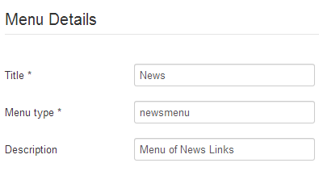

  - Title *: A proper title for the menu. This is used to identify the menu in the Menu Manager in the backend.
  - Menu type *: This should be a unique identification name used by Joomla! to identify this menu. Spaces are not allowed but you may use the '-' character such as news-menu.
  - Description: A description of the menu, useful for your own reference.
5. Click the Save toolbar button to create the new menu.
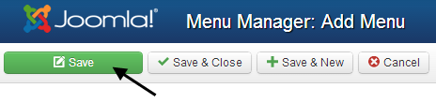

Adding a new menu item
To add a new Menu Item:
- Log in to the Joomla! back-end.
- If needed, create a new Menu using the Menu Manager.
- Open the Menu Item Manager in one of the following ways:
  - Select the Menu you wish to add an item to from the "Menus" drop-down menu.
  - From the Menu Manager, click the Edit Menu Item(s) icon for the desired Menu.
- In the Menu Item Manager, click the New toolbar button to open the Menu Item: New screen.
- Select the appropriate menu item type. For example to insert a single Article select Internal Link > Articles > Article Layout.
- Complete the Menu Item Details section as required. Each Menu Item Type will have it's own parameters to complete as well as common parameters and Menu Item Details.

