Joomla 3.5.1 Installation process for Ubuntu

Step-1: Update Linux Repository.

#apt-get update
Note: No need to follow steps 2-4, if MYSQL, PHP & Apache are already installed. Check their availability with following command in Terminal.
#dpkg -l | grep mysql
#dpkg -l | grep php5
#dpkg -l | grep apache2

Step-2: Install MYSQL server
#apt-get install mysql-server-5.5

Step-3: Install PHP
#apt-get install php5

Step-4: Install apache2
#apt-get install apache2

Step-5: Restart services
#/etc/init.d/apache2 restart
#/etc/init.d/mysql restart

Step-6: Download Joomla package from Joomla official website
i)Create directory joomla in the default apache folder /var/www/ and Download joomla 3.5.1 from joomla official website through wget command in /var/www/joomla/ folder and Unzip it in /var/www/joomla/ folder following command:
#mkdir /var/www/joomla
#cd /var/www/joomla
#wget https://github.com/joomla/joomla-cms/releases/download/3.5.1/Joomla_3.5.1-Stable-Full_Package.zip
# unzip -q Joomla_3.5.1-Stable-Full_Package.zip -d /var/www/joomla
ii)#chown -R root.root /var/www/joomla/
#chmod -R 777 /var/www/joomla/

Step-7: Run the installation script:
i)Open your favorite web browser and connect to your server by name or IP address
website (e.g., http://localhost/joomla).
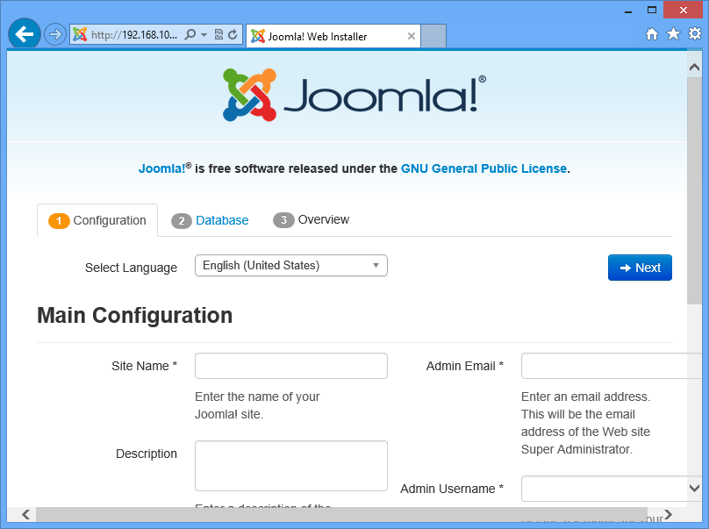
On the Configure site page, do the following:
Site Name = joomla test site
Description = joomla test site
Admin Email = akhilesh.sankhwar@tiss.edu
Admin Username = admin
Admin password = library
Confirm Admin Password = library

ii)After giving the values press Next:
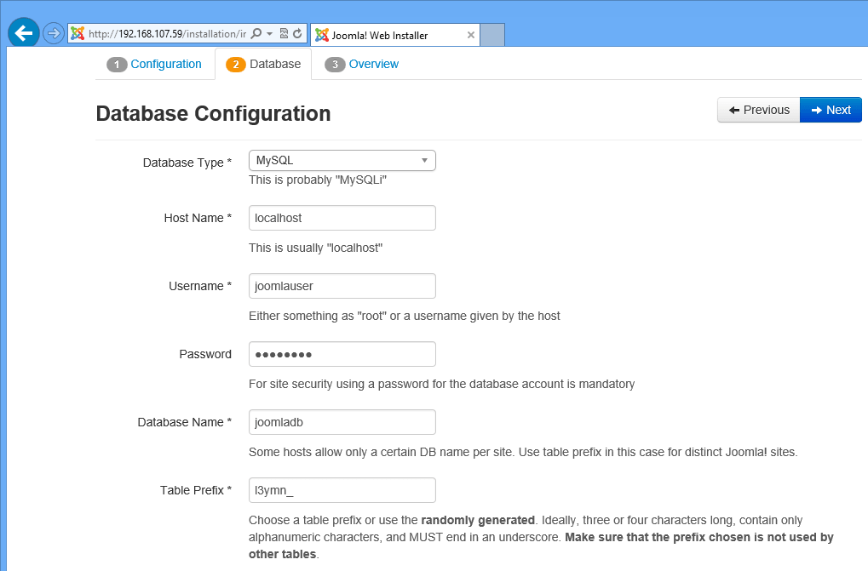
Further fill the values in next page as you mentioned wile creating the database of the joomladb, as in my case I gave the values as follows:
Database Type =MySQLi
hostname = localhost
username = root
password = library
Database Name = joomladb
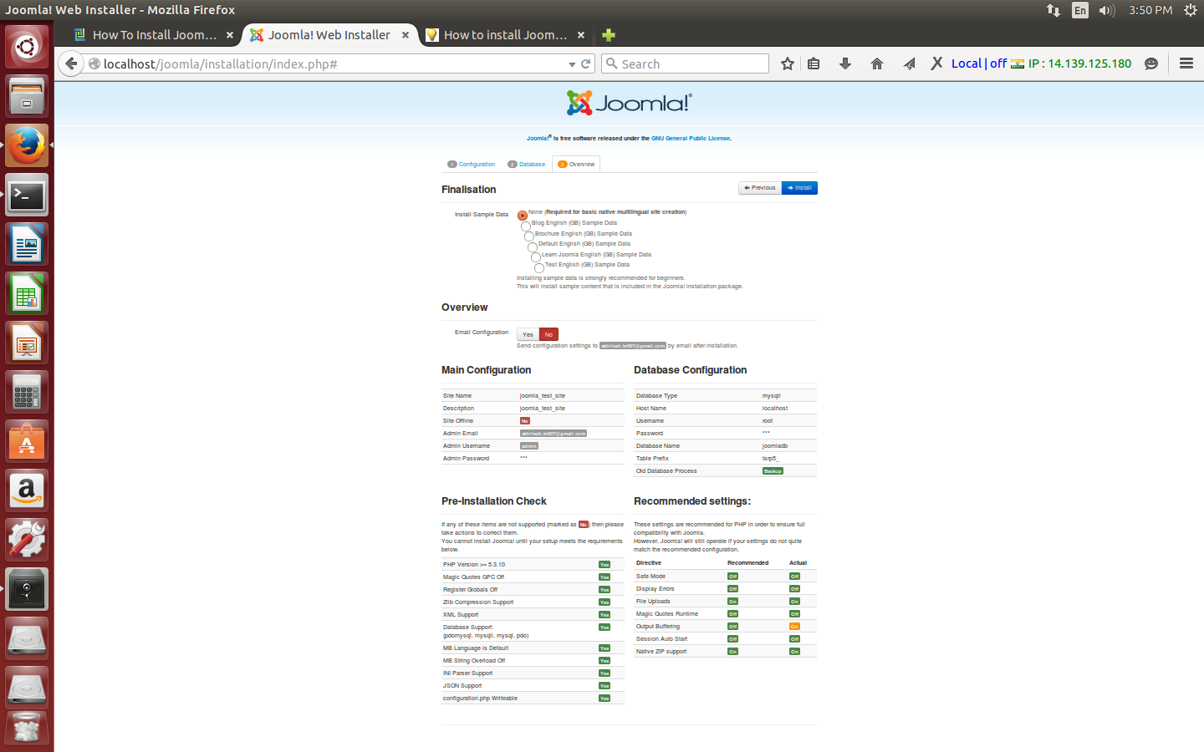
Table Prefix = y2t5p_
iii) For Table Prefix you can use any character as I gave y2t5p_ in my case. Press Next:

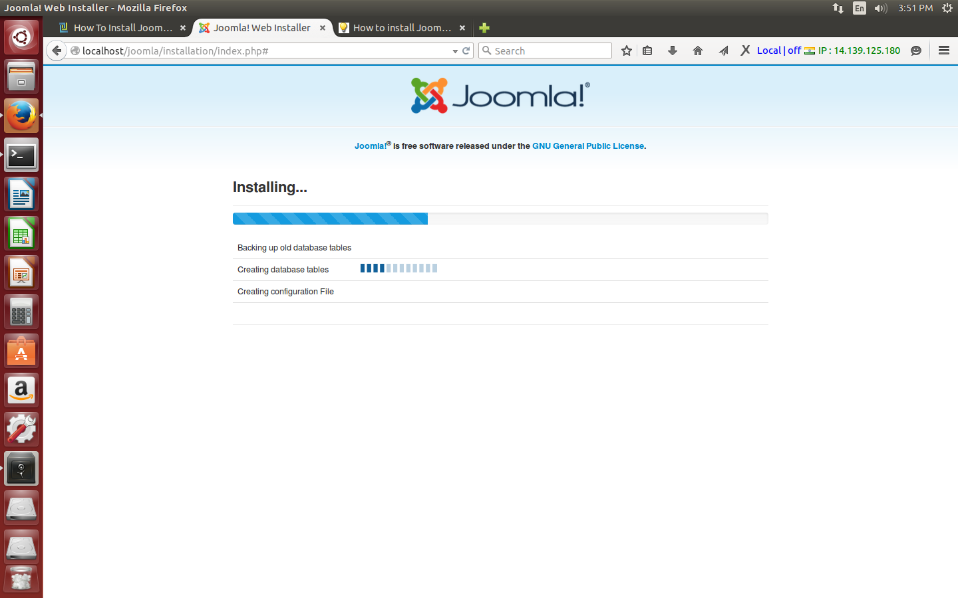
iv)For then next tab I will select the None (install sample data option) and press Install:

Step-8:
On the Joomla installation complete page, click the Visit your new site link.
http://localhost/joomla/
Below link for admin:
http://localhost/joomla/administrator/

