Drupal 9.5.11 Installation process for Ubuntu OS 20.04
Step-1: Update Linux Repository.
#apt-get update
Note: No need to follow steps 2-4, if MariaDB, PHP & Apache are already installed. Check their availability with following command in Terminal.
#dpkg -l | grep mariadb
#dpkg -l | grep php7
#dpkg -l | grep apache2
Step-2: Install MariaDB database server
#apt-get install mariadb-server mariadb-client
Step-3: Install PHP
#apt-get install php php-{cli,fpm,json,common,mysql,zip,gd,intl,mbstring,curl,xml,pear,tidy,soap,bcmath,xmlrpc}
Step-4: Install apache2 Web Server
#apt-get install apache2 libapache2-mod-php
Step-5: Restart services if now working First check the status as same
#/etc/init.d/apache2 status
#/etc/init.d/mysql status
#/etc/init.d/apache2 restart
#/etc/init.d/mysql restart

Step-6: a) On production servers, you must enable some basic security measures for the MariaDB database installation, by running the following security script which ships with the MariaDB package. After running the script, it will take you through a series of questions where you can answer yes(y) to enable some basic security options as shown.

#mysql_secure_installation
Enter current password for root (enter for none): Just press the Enter
Set root password? [Y/n]: Y
New password: Enter password
Re-enter new password: Repeat password
Remove anonymous users? [Y/n]: Y
Disallow root login remotely? [Y/n]: Y
Remove test database and access to it? [Y/n]: Y
Reload privilege tables now? [Y/n]: Y
b) Allow normal users to login as root user with a password.

#mysql -u root
MariaDB [(none)]> UPDATE mysql.user SET plugin = 'mysql_native_password' WHERE User = 'root';
MariaDB [(none)]> FLUSH PRIVILEGES;
quit

c) Create database drupal9 in MariaDB and GRANT All privileges: (Because Drupal stores all site information in a database, you must create this database in order to install Drupal, and grant Drupal certain database privileges (such as the ability to create tables)).

#mysql -u root -p
MariaDB [(none)]>create database drupal9;
MariaDB [(none)]>GRANT ALL PRIVILEGES ON drupal9.* TO root@localhost;
MariaDB [(none)]> FLUSH PRIVILEGES;
MariaDB [(none)]>quit
Step-7: Download Drupal 9.5.11 tar package from drupal Official website in html folder
i)
Download Drupal 9.5.11 software package through wget command in /var/www/html/ folder and Unzip it in /var/www/html folder following command:
#cd /var/www/html/
#wget https://ftp.drupal.org/files/projects/drupal-9.5.11.tar.gz
#tar -zxvf drupal-9.5.11.tar.gz
ii)
rename of folder name
#mv drupal-9.5.11 drupal9
iii)
#chmod -R 777 /var/www/html/drupal9/sites/default
#mkdir /var/www/html/drupal9/sites/default/files
#chmod -R 777 /var/www/html/drupal9/sites/default/files
iv)
#cp /var/www/html/drupal9/sites/default/default.settings.php /var/www/html/drupal9/sites/default/settings.php
# chmod -R 777 /var/www/html/drupal9/sites/default/settings.php

Step-8: Run the installation script:
i)To run the installation script, point your browser to the base URL of your
website (e.g., http://localhost/drupal9).
ii)On the Choose language page, select English. Click Save and continue.
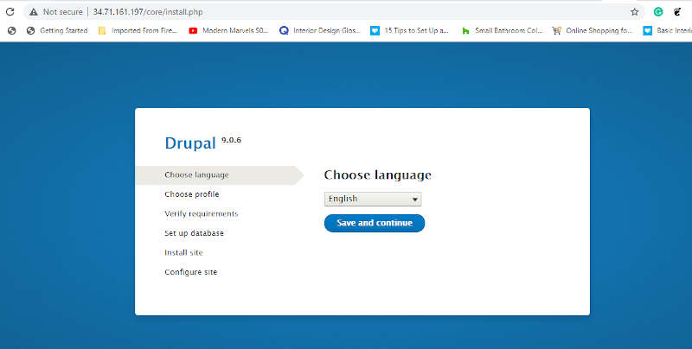
On the

iii) Select an installation profile page, select Standard. Click Save and continue.
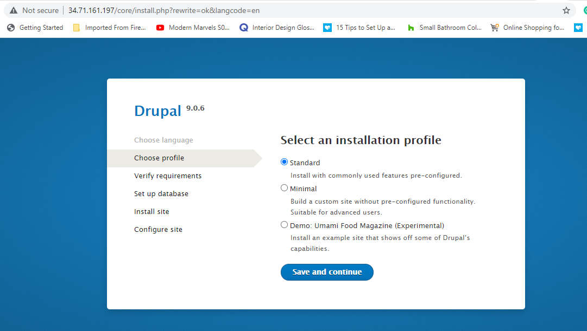
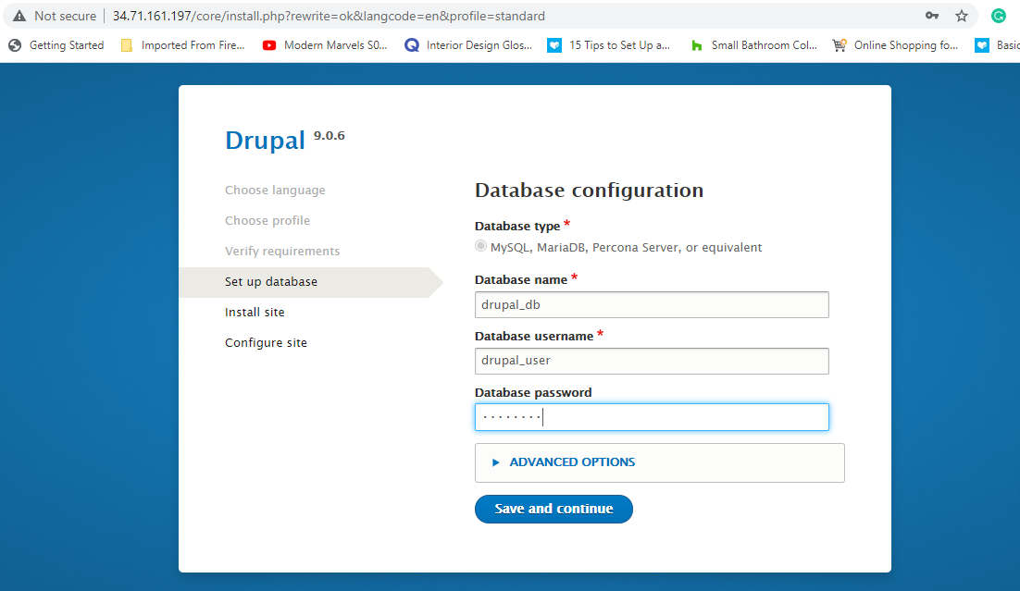
iv)On the Database configuration page, select the type of database that you are using. Type the database name, database username and database password (the same ones you used to set up your database).

Click Save and continue. The Installing Drupal page is displayed.
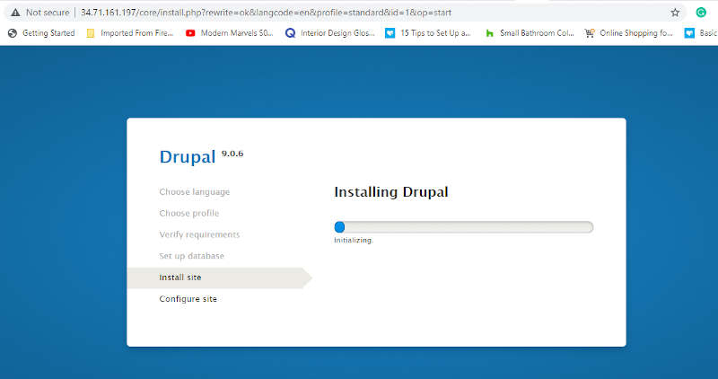
Step:9
On the Configure site page, do the following:
- In the Site name field, type the name you want to give your site. In the Site email address field, type the email address that automated messages from your Drupal site will be sent from.
- In the site maintenance account section, type a username, email address and password to use for the maintenance account.
- In the server settings section, select a country from the list and then select a time zone.
- If desired, select Check for updates automatically and Receive email notifications (recommended to keep your site's security up to date).
- Click Save and continue.
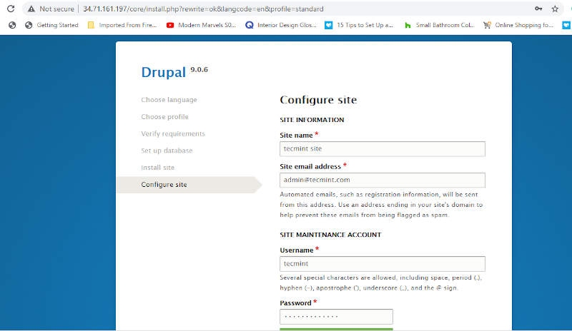
Step:10
On the Drupal 9 installation complete page, Finally, you will get the default dashboard for Drupal as shown:
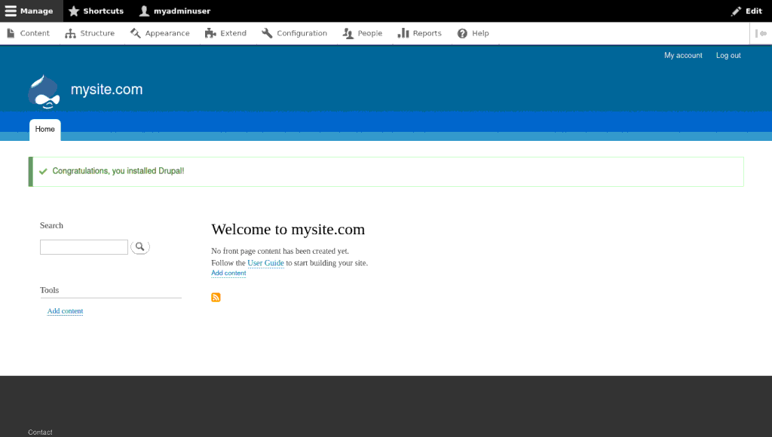

You should see a newly installed Drupal homepage, as shown in the screenshot above. The administrator account is automatically logged in, and if you chose the "Standard" install, the black administration toolbar will be displayed across the top of the page.

Website Content Developing
1) Log In your drupal newly installed website

2) Install New theme "Business Responsive"

# cd /var/www/html/drupal9/core/themes/
# wget https://ftp.drupal.org/files/projects/business_responsive_theme-2.0.3.tar.gz
# tar -zxvf business_responsive_theme-2.0.3.tar.gz

Go to Administrator appearance section -> install themes and enable as default

3) Create 4 main menus i. e. ;
-→1)About us 2)Services 3)Resources 4) Contact us

4) Create 2 Basic page (with one paragraph text) each of the above the main menus and make it as sub menu

5) Create 2 menus with External links i.e.
--> 5) Shodhganga 6) INFLIBNET

6) Create a "News &Update " block under "Sidebar" and add following 5 news;
-->Admission open for the academic year 2023-24
-->National conference on Feature Librarianship on 11-12 Dec. 2023 at. TISS
-->Applications are invited for Ph.D. in LIS
-->PGDLIM convention on 5thOctober 2023
-->Guest Lecture on Research method in LIS on 12th Dec 2023

7) Add/publish one content on front page

8) Create Footer as like;
--> footer 1) OPAC
-->footer 2)€-Resources
-->footer 3)Remote Access

9) Update copyright information
-->Copyright ©2023. All Rights Reserved, SDTM Library, Mumbai.
Go to Administrator appearance section -> then Click on installed and default themes Settings -> click Copyright -> update new copyright content, then save configuration.

10) Change the Header Logo/Text (header image will be provide on practical)
Go to Administrator appearance section -> then Click on installed and default themes Settings -> Logo image -> browse and upload new logo image, then save configuration.

Go to Administrator Appearance section: Click on Settings of default themes → Logo image settings

11) Change the slide shows images from "slide" folder (folder will be given on practicals )

12) Enable the Search Box top of the Sidebar

13) Enable Site hits on sidebar
14. Add new Admin user
15. Social Media Link update
16. Reports

