Joomla 3.9.6 Installation process for Ubuntu OS

Step-1: Update Linux Repository.
#apt-get update
Note: No need to follow steps 2-4, if MYSQL, PHP & Apache are already installed. Check their availability with following command in Terminal.
#dpkg -l | grep mysql
#dpkg -l | grep php5
#dpkg -l | grep apache2

Step-2: Install MYSQL server
#apt-get install mysql-server-5.5

Step-3: Install PHP
#apt-get install php5

Step-4: Install apache2
#apt-get install apache2

Step-5: Restart services such as apache2/mysql, if not working
#/etc/init.d/apache2 restart
#/etc/init.d/mysql restart

Step-6: Create database joomladb in MYSQL and GRANT All privileges
(Because Joomla stores all site information in a database, you must create
this database in order to install Joomla, and grant Joomla certain database
privileges (such as the ability to create tables)).
#mysql -u root -p;
mysql>create database joomladb;
mysql>GRANT ALL PRIVILEGES ON joomladb.* TO root@localhost;
mysql>quit

Step-7: Download Joomla package from Joomla official website
i)Create directory joomla in the default apache folder /var/www/ and Download joomla 3.9.6 version from joomla official website through wget command in /var/www/joomla/ folder and Unzip it in /var/www/joomla folder following command:
#mkdir /var/www/joomla
#cd /var/www/joomla
#wget https://downloads.joomla.org/cms/joomla3/3-9-6/Joomla_3-9-6-Stable-Full_Package.zip
# unzip -q Joomla_3-9-6-Stable-Full_Package.zip -d /var/www/joomla
ii)#chown -R root.root /var/www/joomla/
#chmod -R 777 /var/www/joomla/

Step-8: Run the installation script:
i)Open your favorite web browser and connect to your server by name or IP address
website (e.g., http://localhost/joomla).
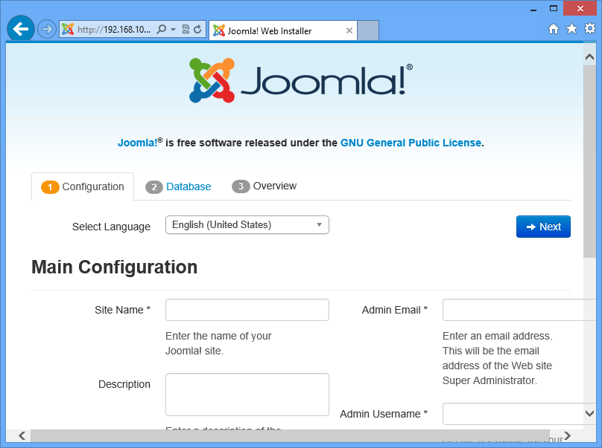

On the Configure site page, do the following:
Site Name = Joomla Test site
Description = joomla Test site
Admin Email = akhilesh.sankhwar@tiss.edu
Admin Username = admin
Admin password = library
Confirm Admin Password = library

ii)After giving the values press Next:
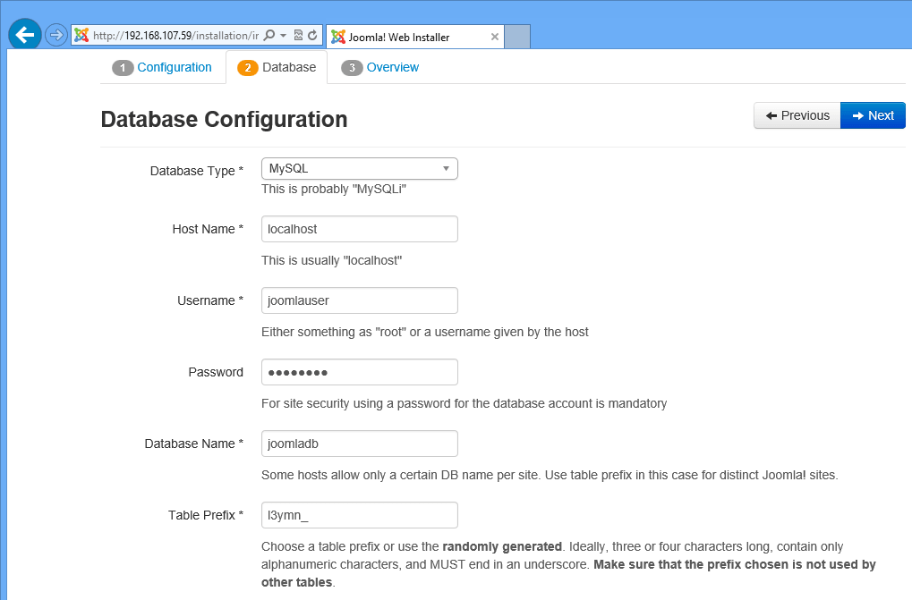

Further fill the values in next page as you mentioned wile creating the database of the joomladb, as in my case I gave the values as follows:
Database Type =MySQLi
hostname = localhost
username = root
password = library
Database Name = joomladb
Table Prefix = I3ymn_
iii) For Table Prefix you can use any character as I gave I3ymn_ in my case. Press Next:
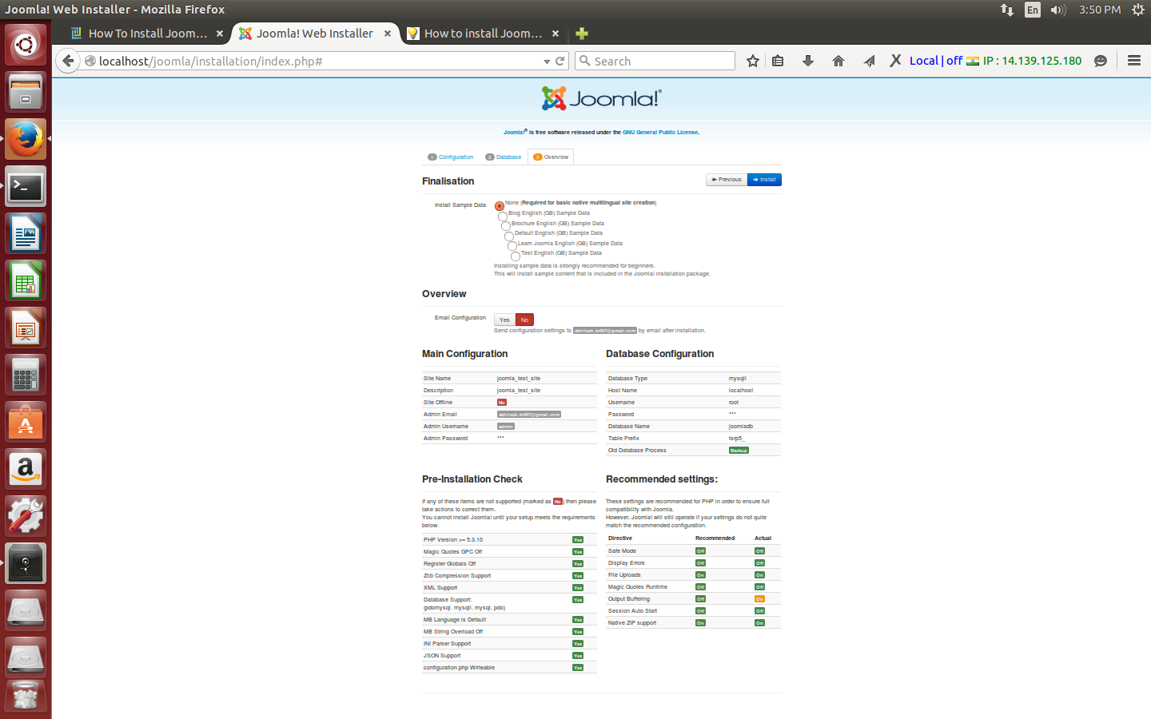

iv)For then next tab I will select the None (install sample data option) and press Install:
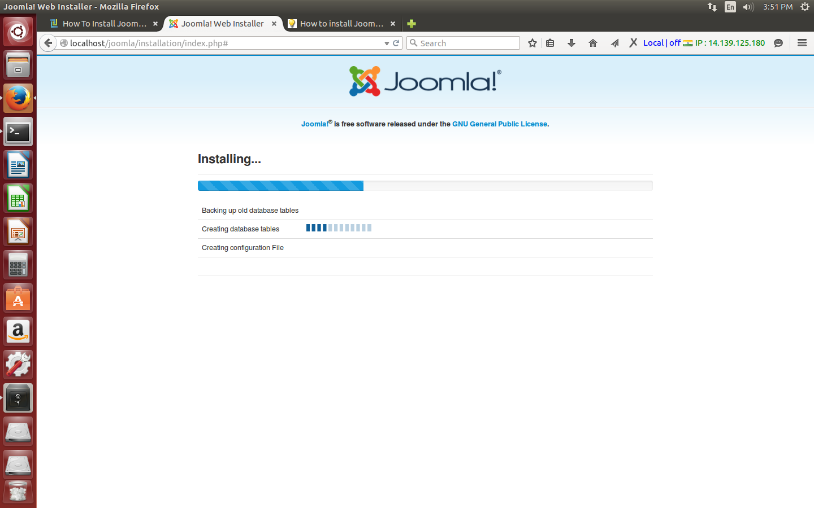

Step-8:
On the Joomla installation complete page, click the Visit your new site link.
http://localhost/joomla/
Below the link for admin:
http://localhost/joomla/administrator/

Note: if you are getting error during installation of joomla as follows:
Installation folder could not be deleted. Please manually delete installation folder
"PLEASE REMEMBER TO COMPLETELY REMOVE THE INSTALLATION FOLDER.
You will not be able to proceed beyond this point until the installation folder
has been removed. This is a security feature of Joomla!."
Please execute below command
#cd joomla
#rm -rf installation/

